HP QC

QC 9.2

All functional test cases and test data are placed in QC.

Launching QC, Requirements, Test Plan, Test lab and Defects are displayed.

Test Plan -- >

Clicking on Test Plan, create new folder called **Salesforce folder**.

Create new test case called **Login with required fields** level – medium or low

priority – high, medium or low

and reviewed - changed, not reviewed or reviewed.

**Details**

**Design Steps:**

**Step name: Launch Application**

**Description**

**Expected Result**

**Attachment**: click on default to attached with current test case. Double click on default, store data in data folder - xl file.

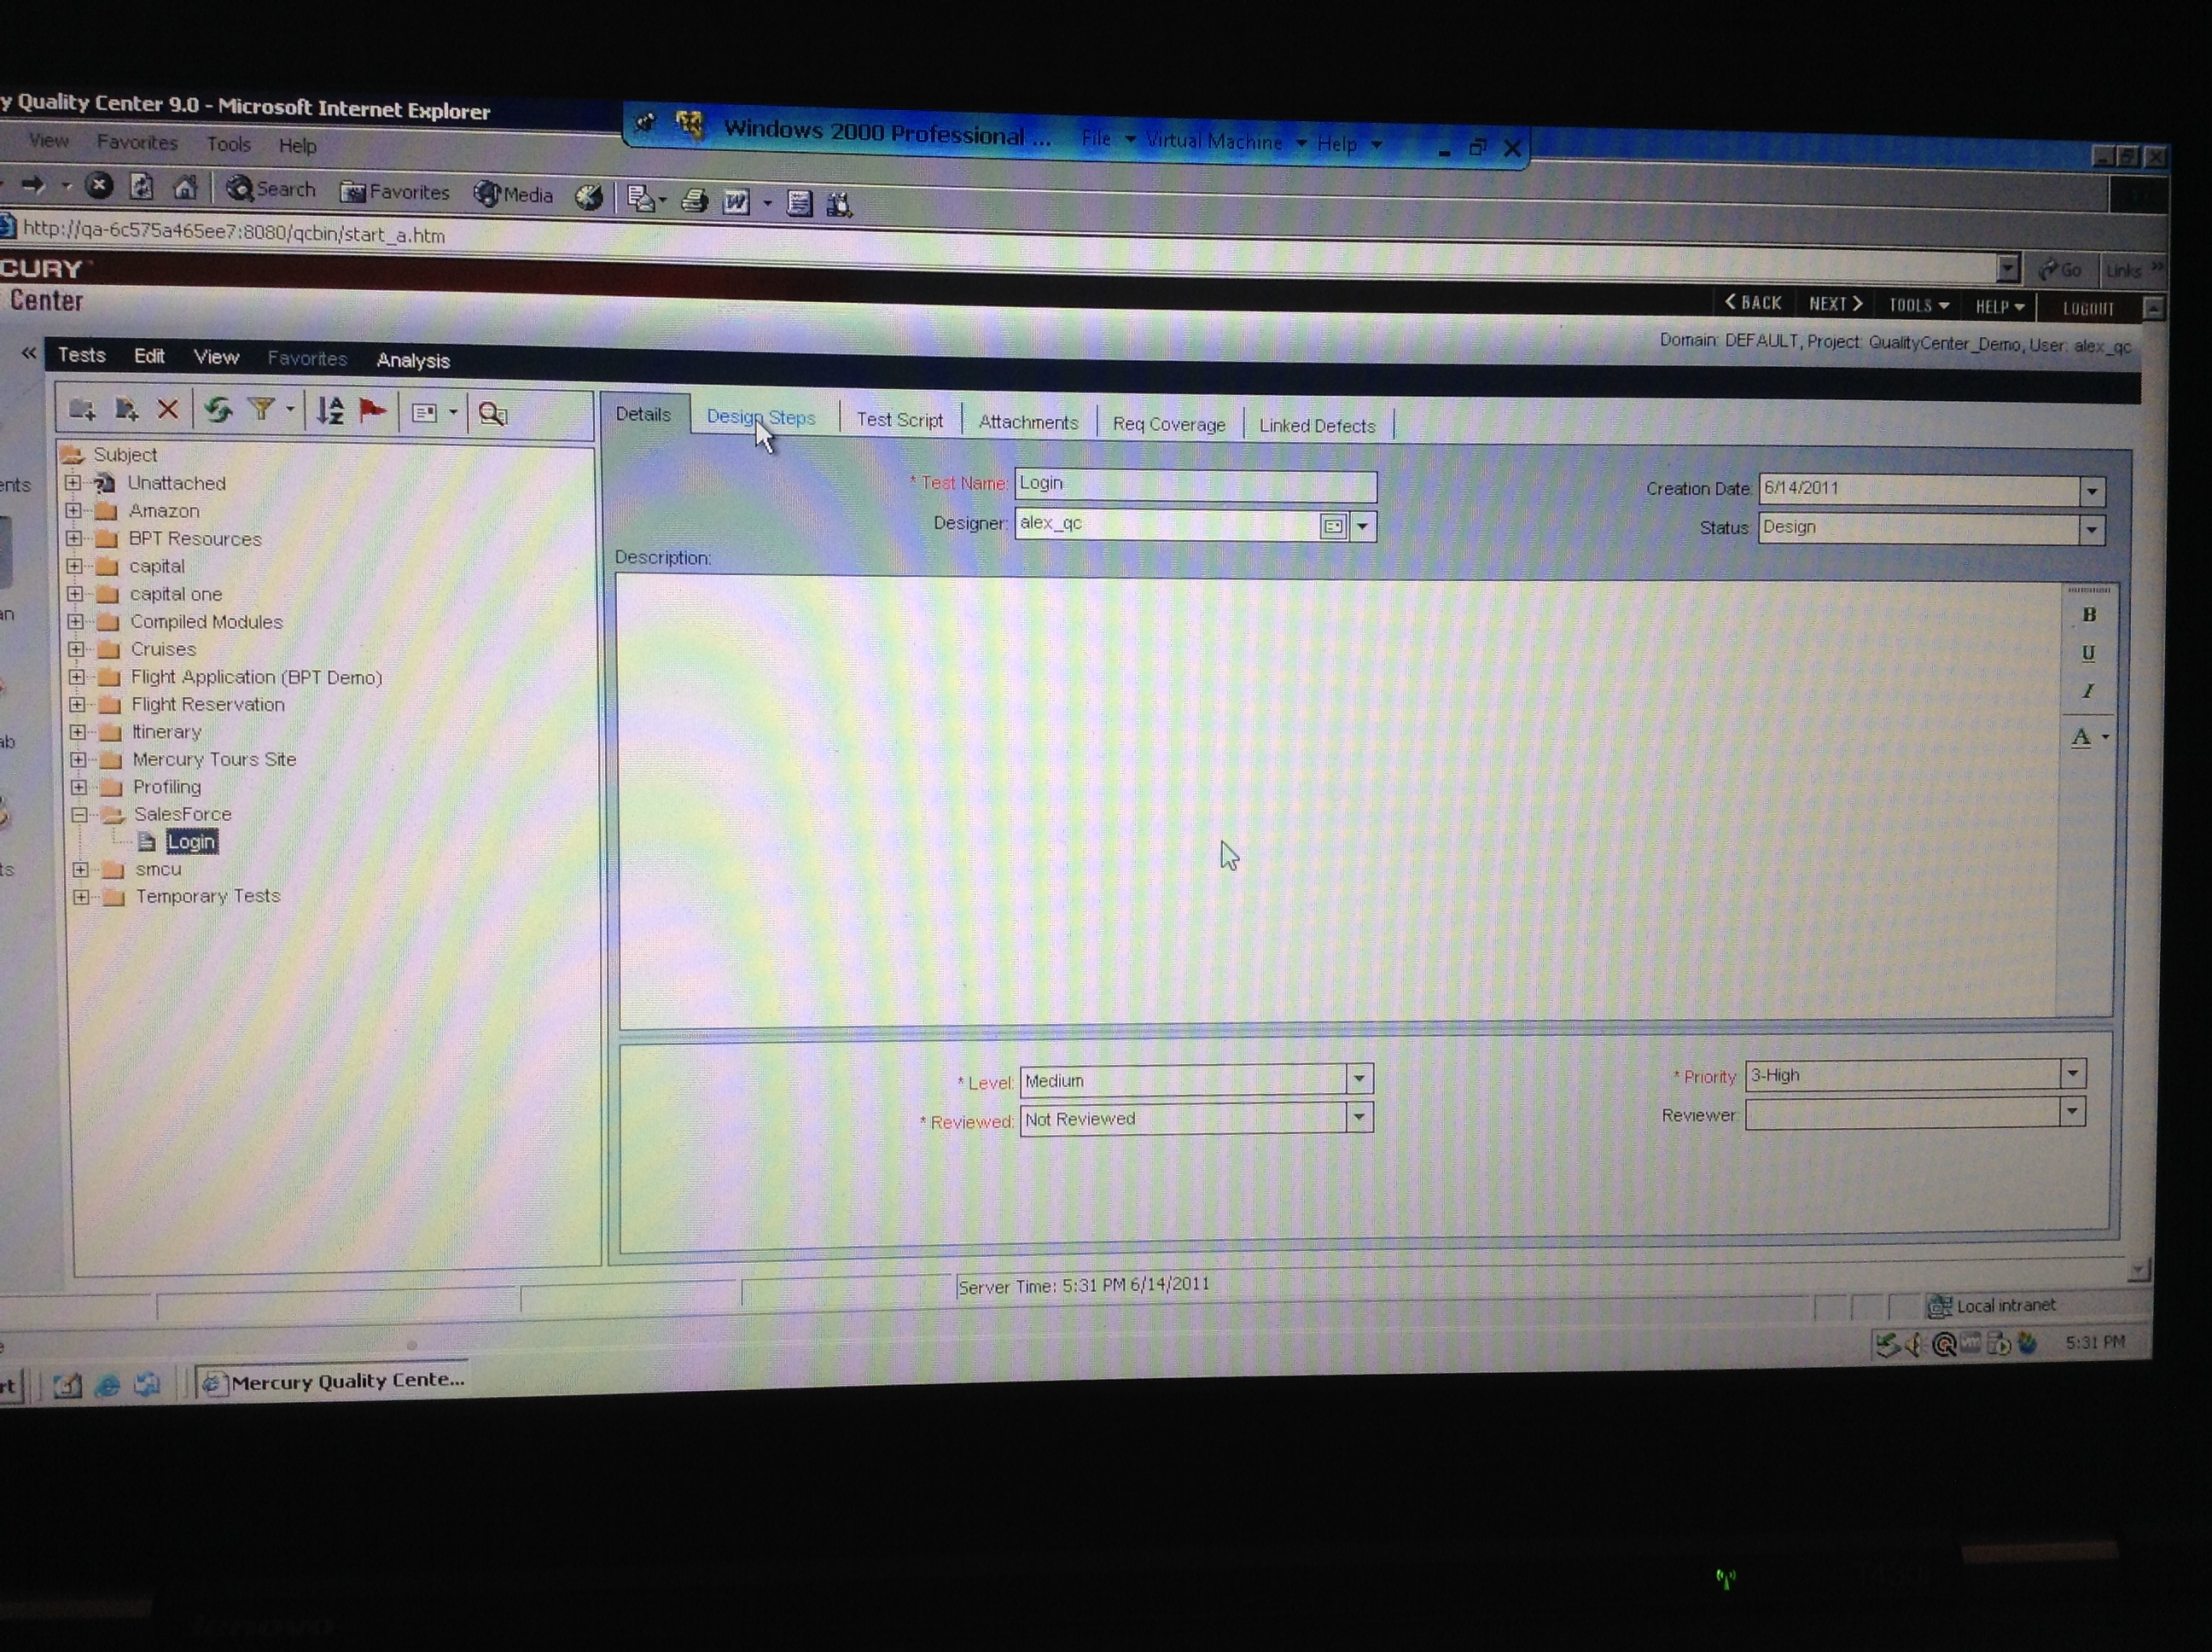

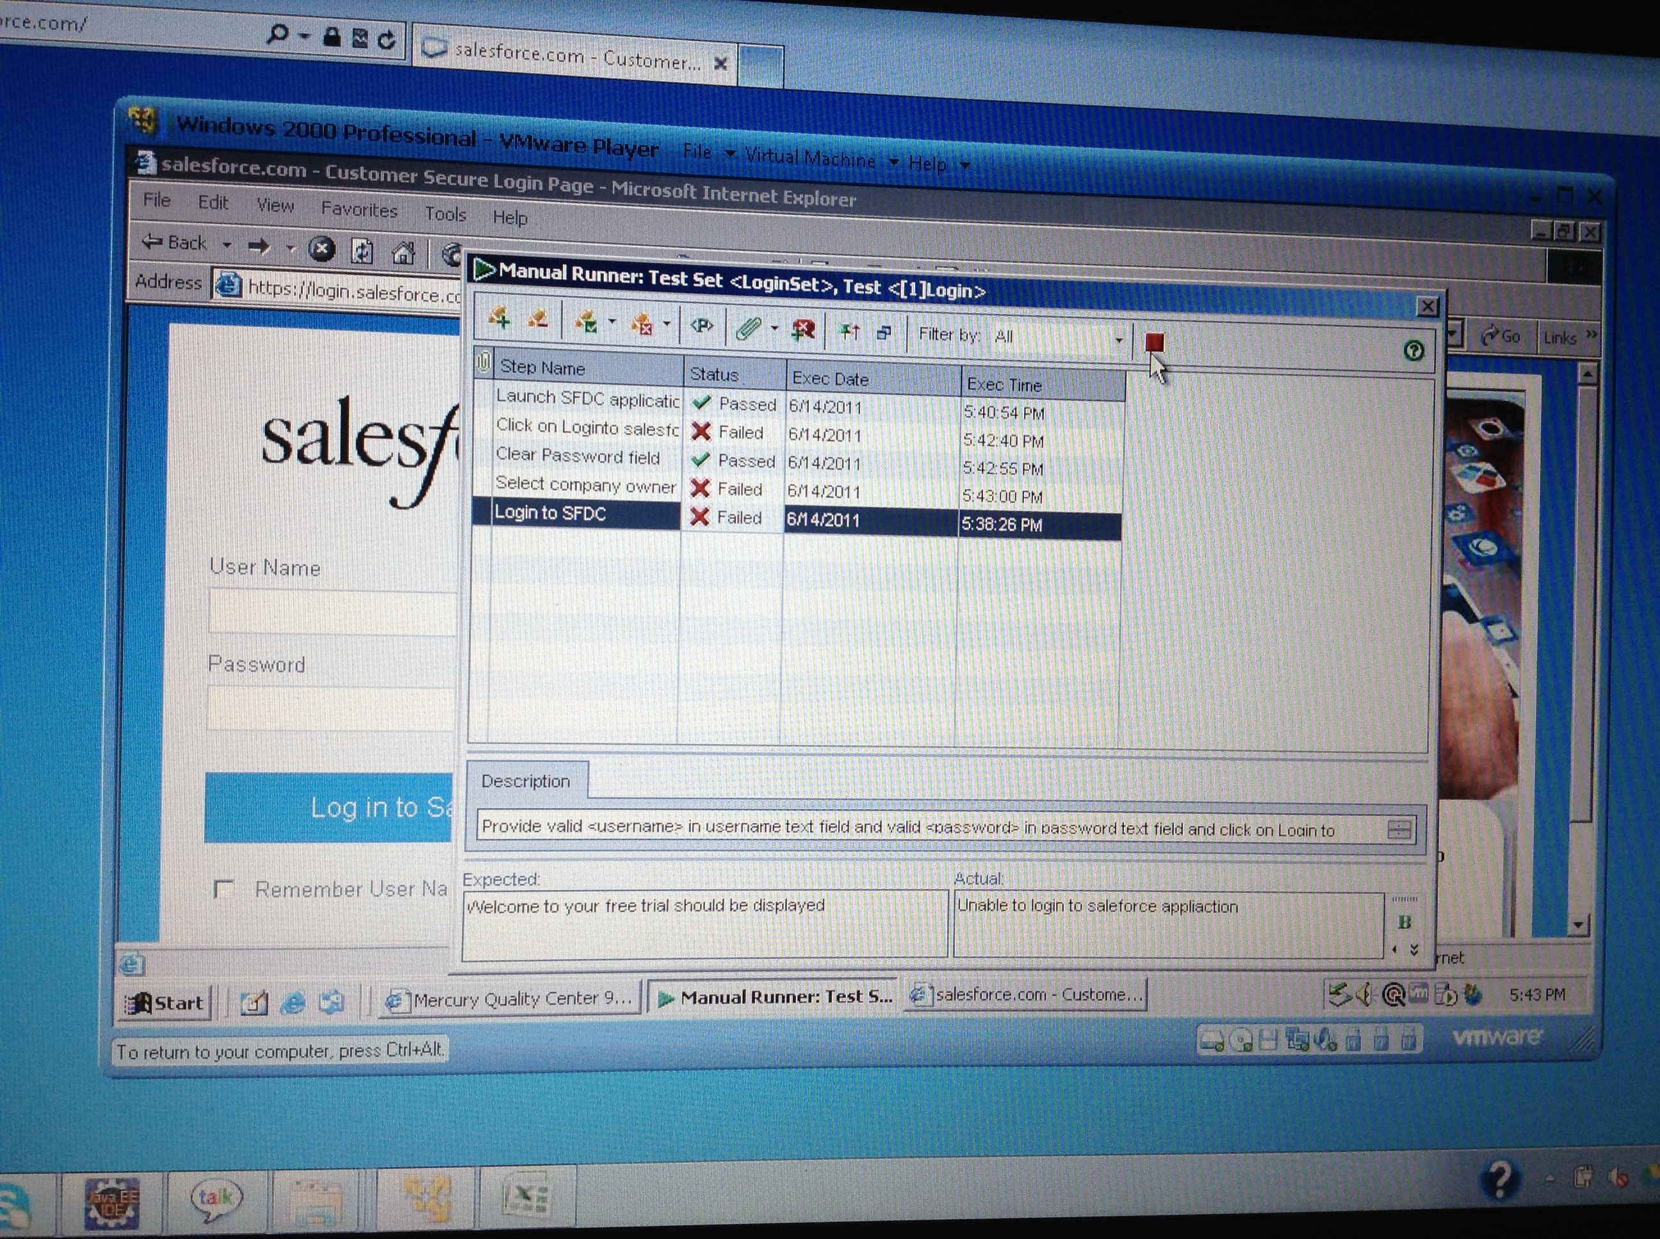

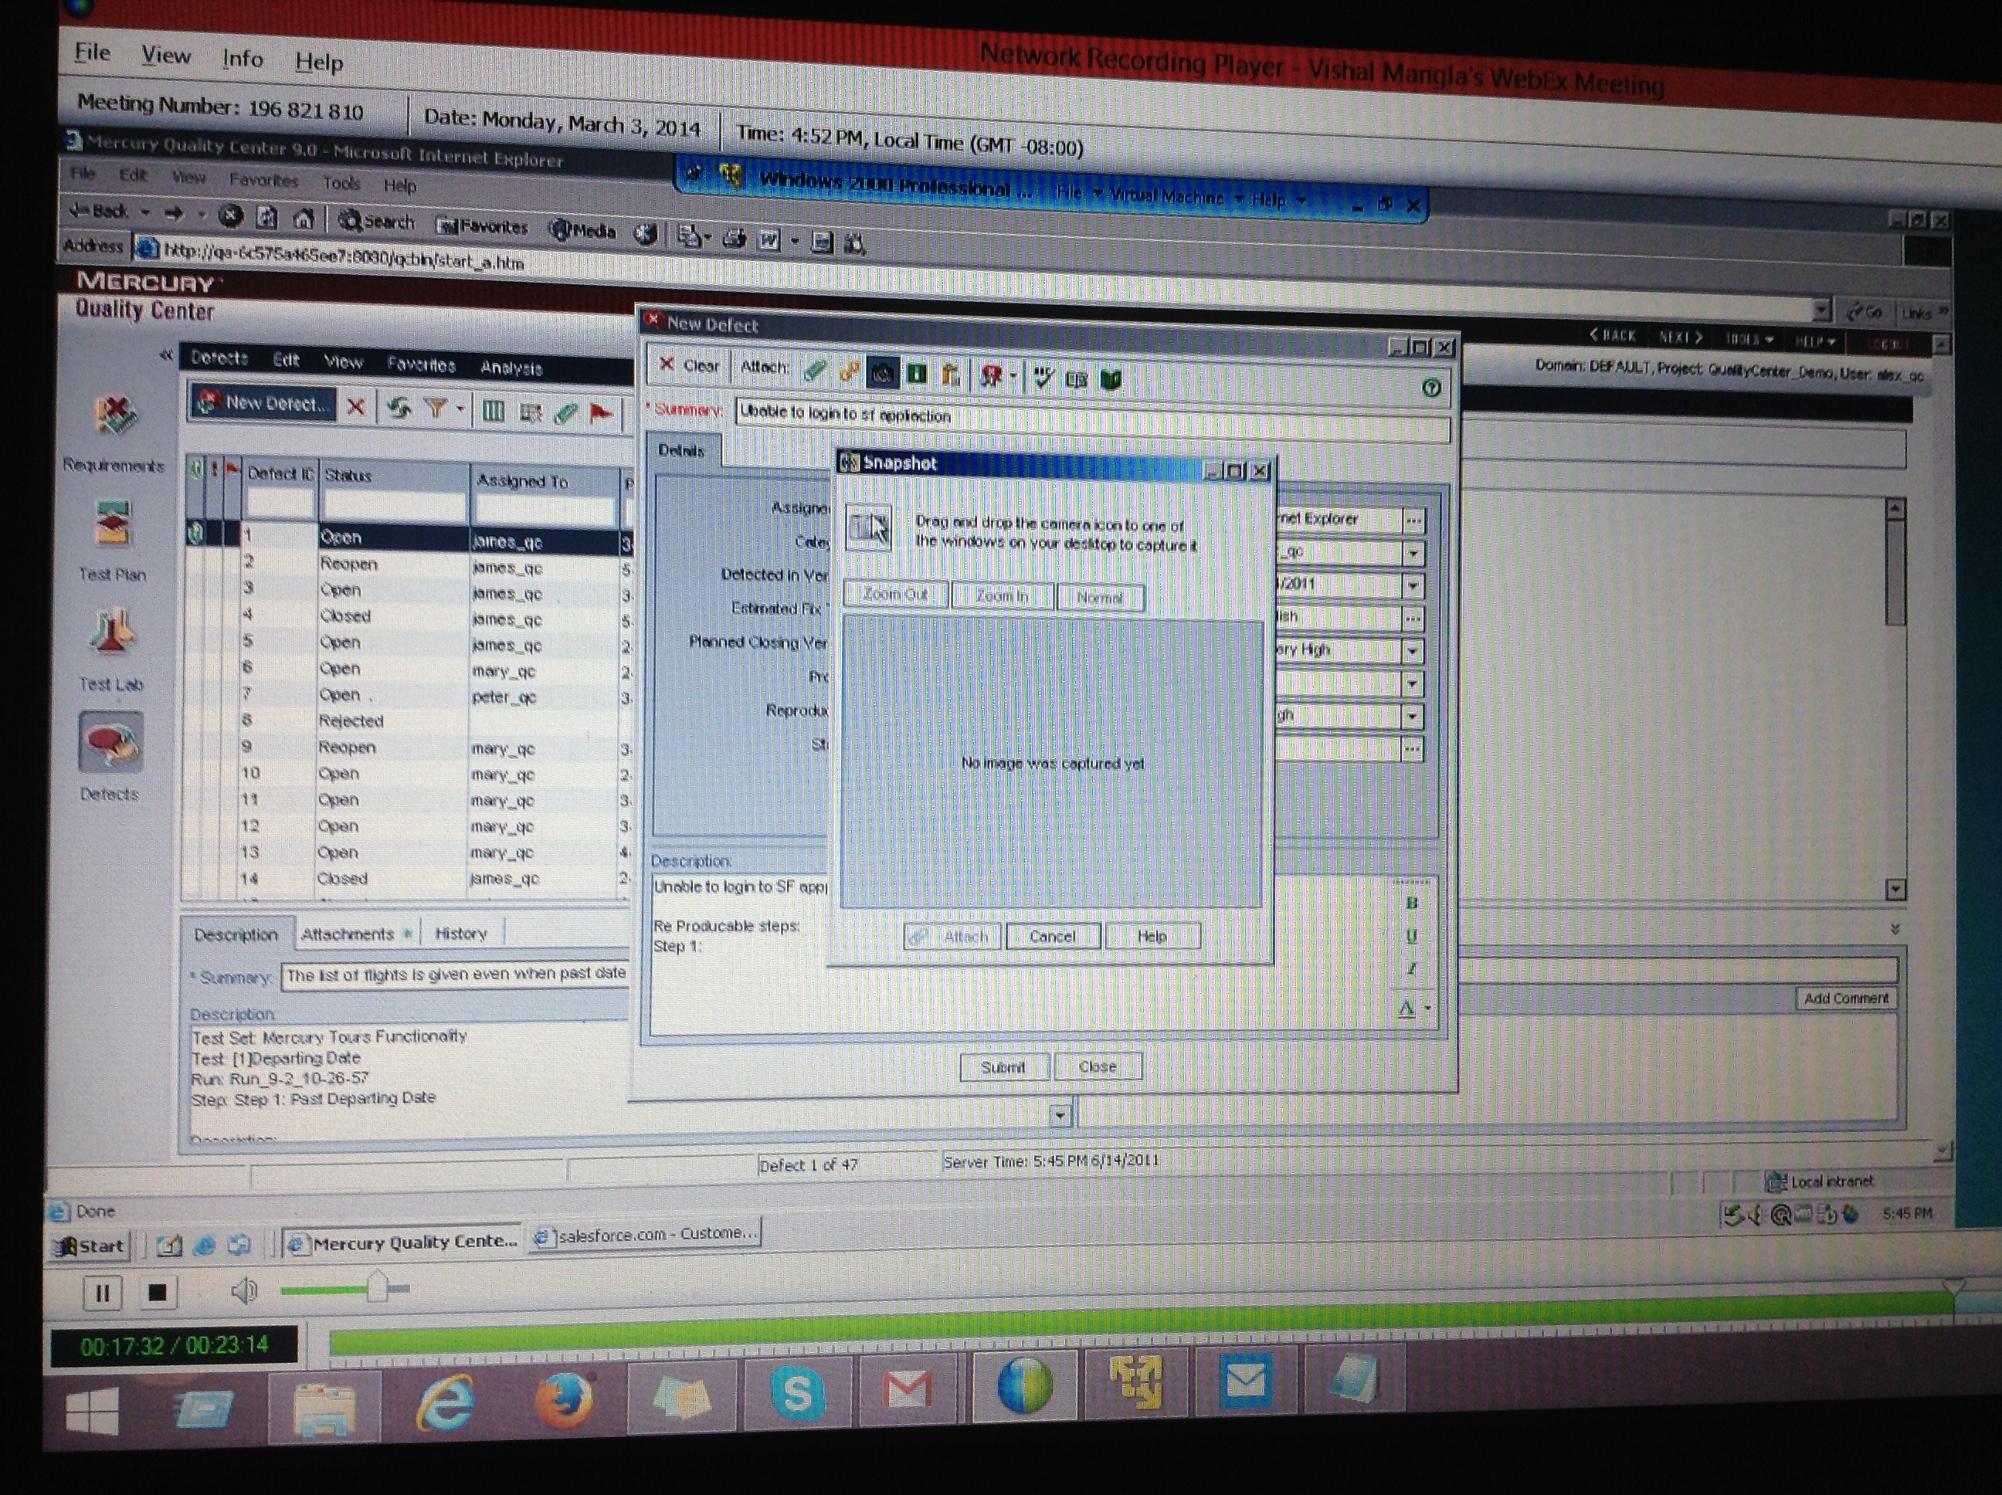

Test Lab -- >

Clicking on Test Lab, create new folder called Salesforce under which create test set Login folder.

Create Test set named Login.

Go to Test Set, Click on Run, click on Begin Run.

Copy test cases from test plan.

Defects -- >

Click on New Defect, New Defect window is displayed.

Recording -- > 6/14/2011 on Mar 3 and 15

QC have not integrated with Selenium.

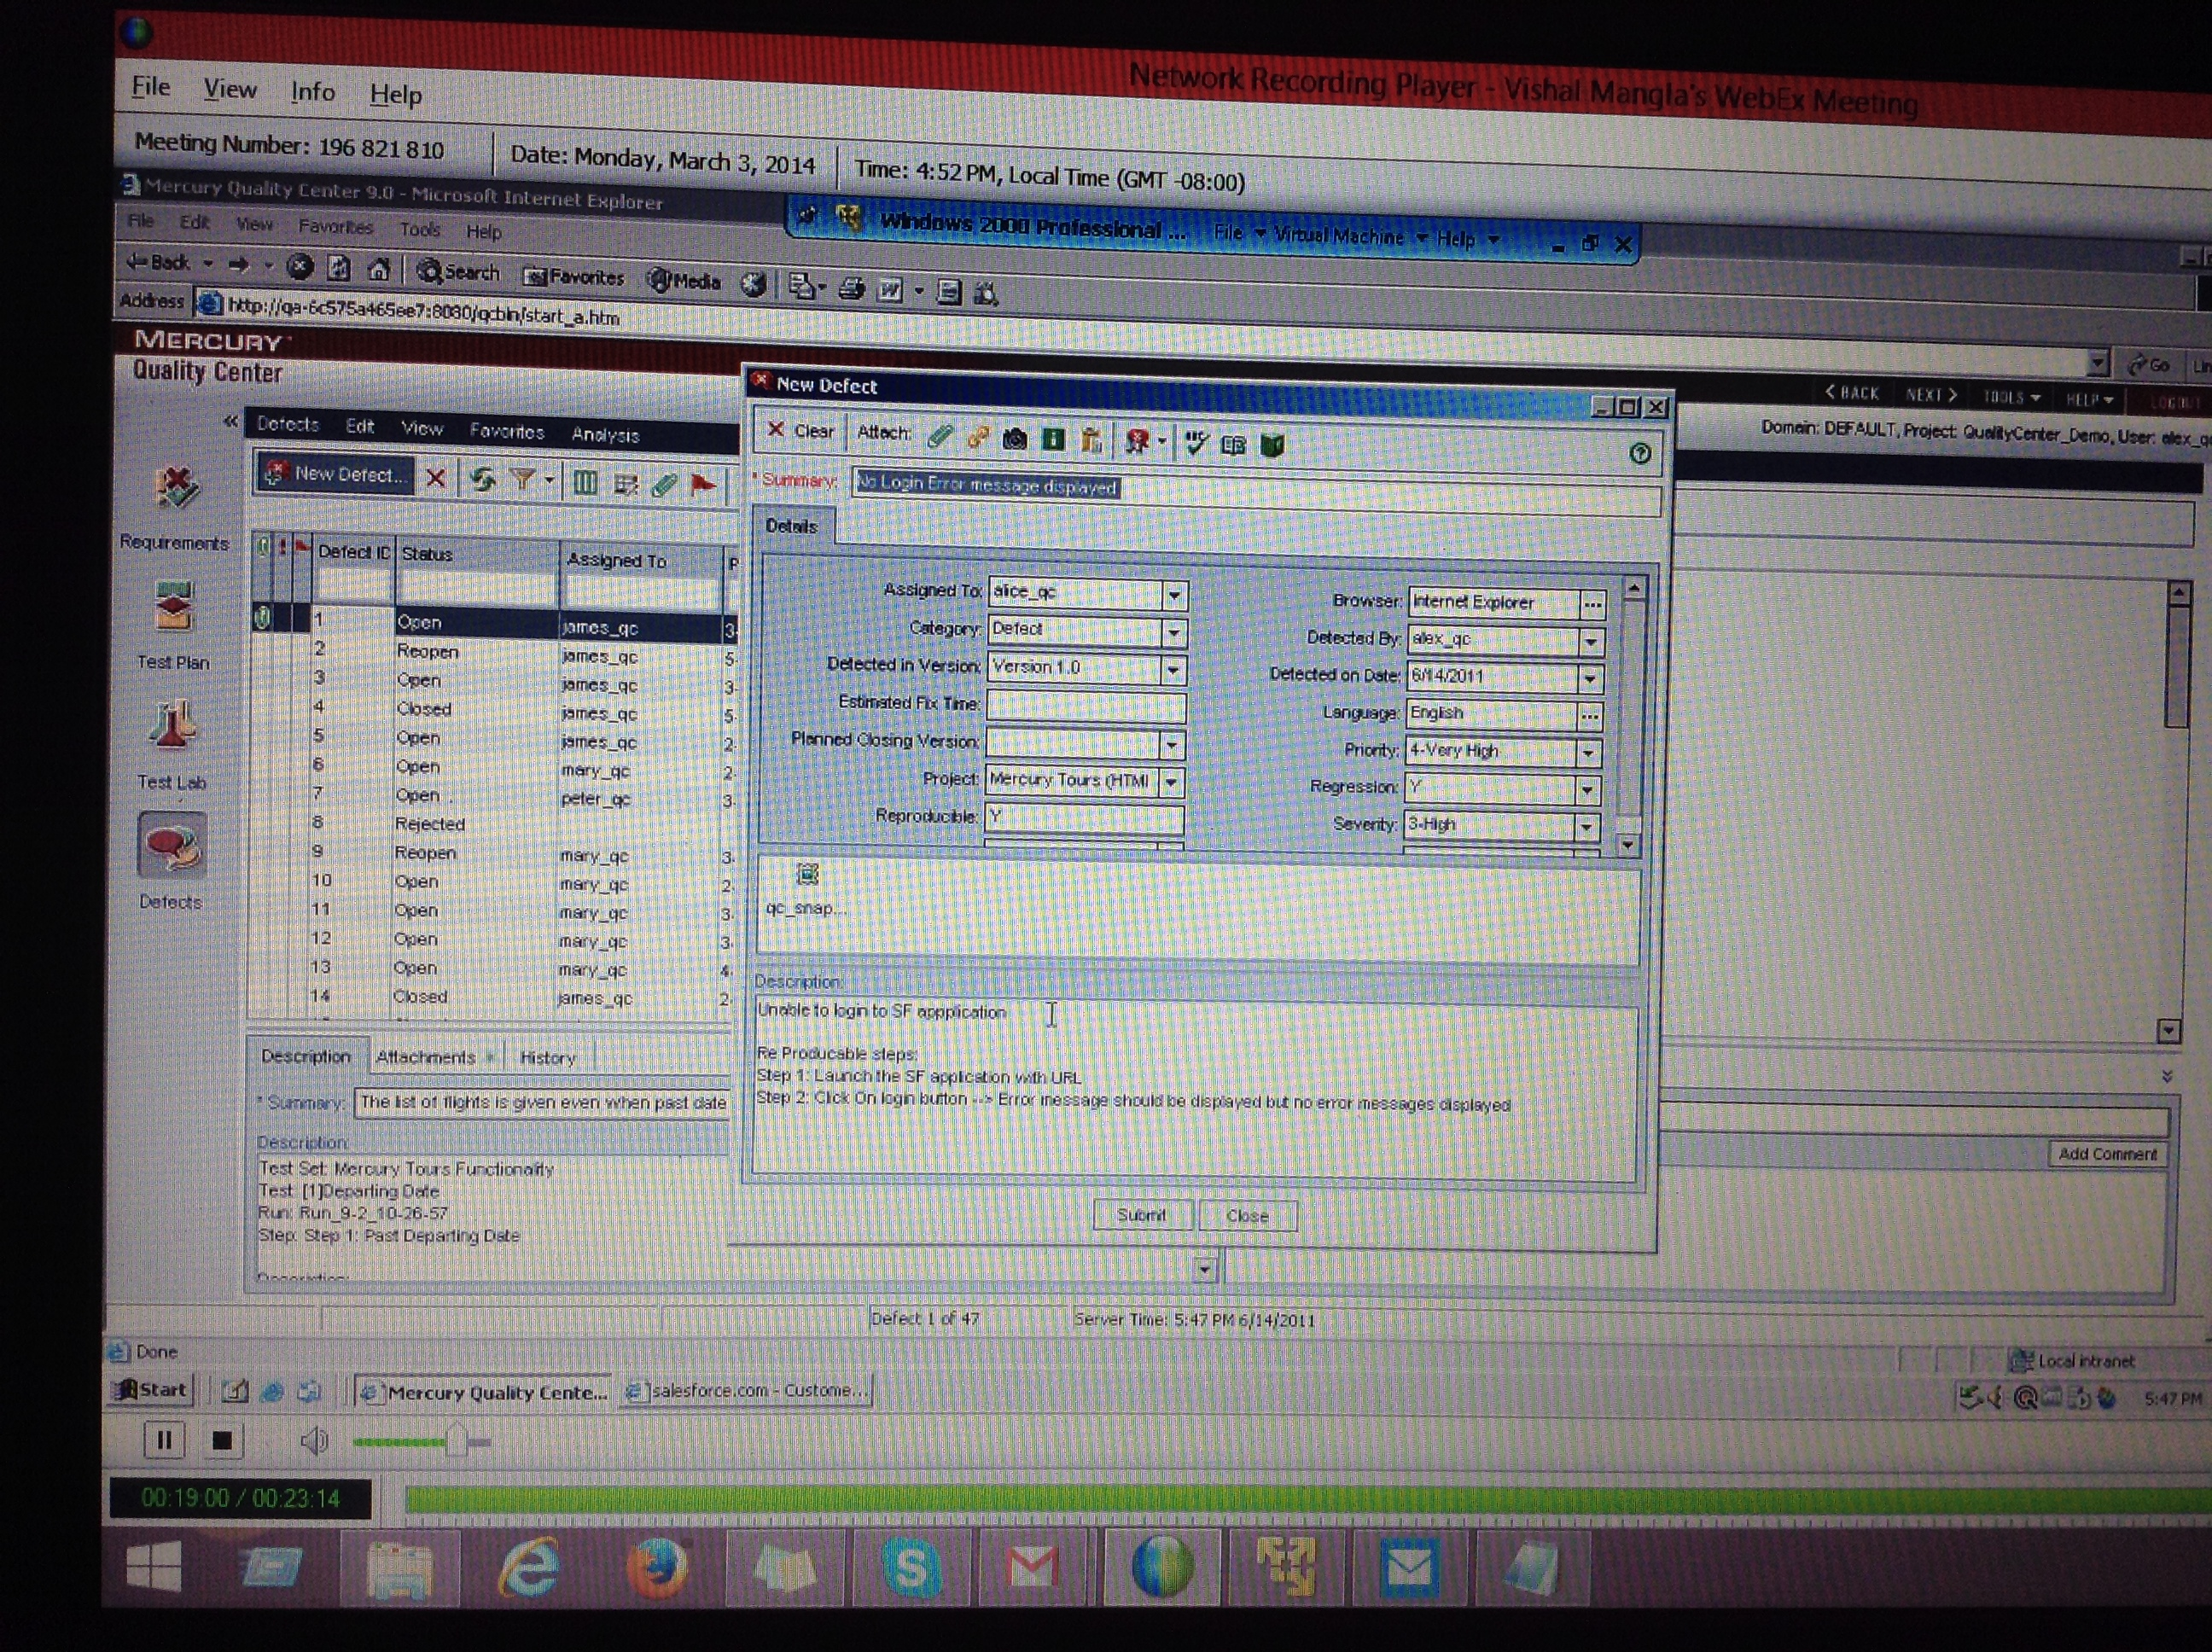

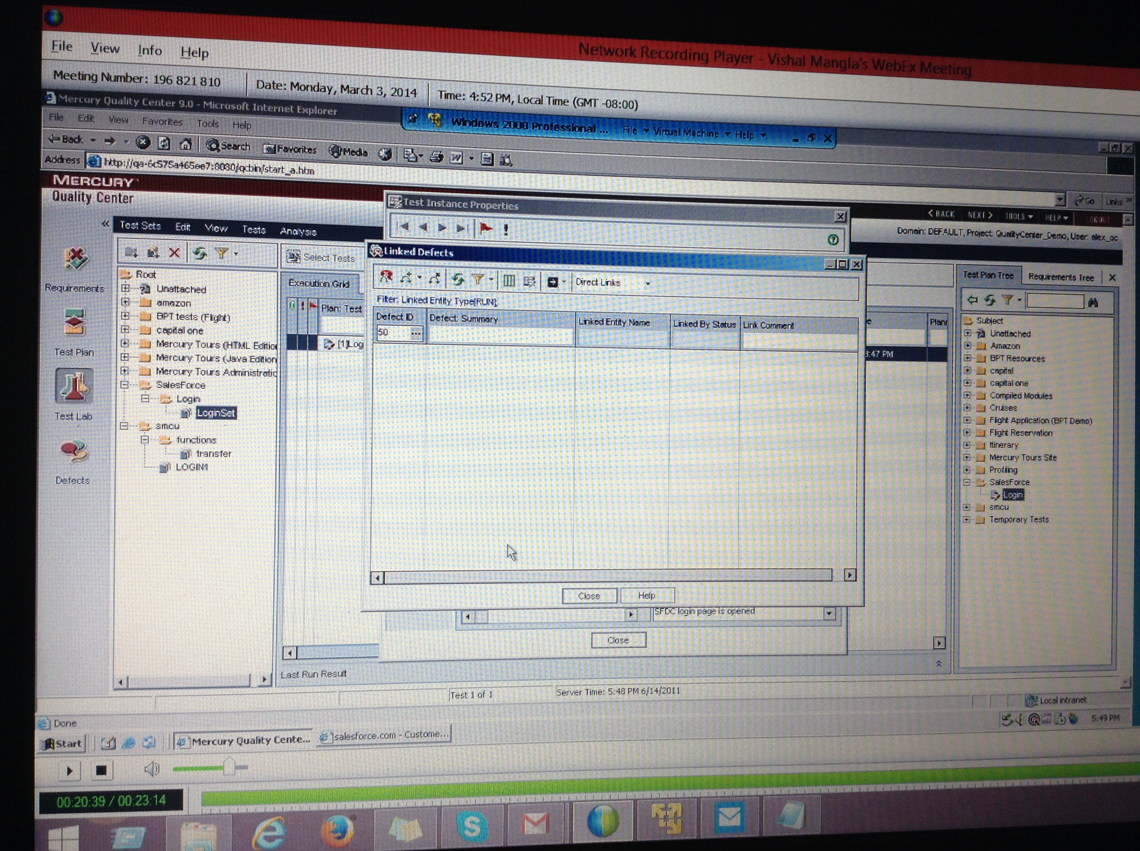

HP QC

HP Quality Center is quality management software offered with many capabilities.

**HP Quality Center offers** [**software quality assurance**](http://en.wikipedia.org/wiki/Software_quality_assurance)**, including user** [**requirements management**](http://en.wikipedia.org/wiki/Requirements_management)**,** [**test management**](http://en.wikipedia.org/wiki/Test_management) **and** [**business process**](http://en.wikipedia.org/wiki/Business_process) **testing for IT and application environments.**

HP Quality Center is a component of the [HP Application Lifecycle Management](http://en.wikipedia.org/wiki/HP_Application_Lifecycle_Management) software solution set.

**HP Quality Center is also available as a Software-as-a-Service offering.**

HP Quality Center is available as HP Quality Center Starter Edition software and HP Quality Center Enterprise software.

## System requirements

### Client

HP Quality Center can be used on Windows platforms with an [Internet Explorer](http://en.wikipedia.org/wiki/Internet_Explorer) browser.

<http://en.wikipedia.org/wiki/HP_Quality_Center>

________________

# Hp-QC Tutorial

**HP Quality Center, a commercial test management tool, supports various phases of software development life cycle.**

**Now it is popularly known as Hp-ALM** [**Application[](http://www.tutorialspoint.com/)**](http://www.tutorialspoint.com/) **Lifecycle Management.**

## What is Quality Center?

HP Quality Center, a test management tool is now popularly known as **A**pplication **L**ifecycle **M**anagement Tool(ALM) as it is no longer just a test management tool but [it supports[](http://www.tutorialspoint.com/)](http://www.tutorialspoint.com/) various phases of the software development life cycle.

**HP-ALM helps us to** [**manage project[](http://www.tutorialspoint.com/)**](http://www.tutorialspoint.com/) **milestones, deliverables, resources and keeping track of project health, standards that allows Product owners to gauge the current status of the product.** It is important to understand history, architecture and Quality Center Workflow.

## History of QC

Quality Center was formerly known as Test Director, a product of mercury interactive. The below table provides us a better insights about the version history of QC.

|  |  |  |  |
| --- | --- | --- | --- |
| **S.No#** | **Commercial Name** | **Version Numbers** | **Owned By** |
| 1. | Test Director | v1.52 to v8.0 | Mercury Interactive |
| 2. | Quality Center | v8.0 to v9.0 | Mercury Interactive |
| 3. | Quality Center | v9.2 to v10.0 | Hp |
| 4. | ALM | v11.0 to v11.5x | Hp |

## Architecture of QC

HP-ALM, an enterprise-wide [application[](http://www.tutorialspoint.com/)](http://www.tutorialspoint.com/) that is based on Java 2 Enterprise Edition (J2EE) technology and uses MS SQL Server or Oracle as its back end. There is also a [load balancer[](http://www.tutorialspoint.com/)](http://www.tutorialspoint.com/) to effectively cater user's requests.

**Site Administration Database is hosted on a standalone** [**Database server[](http://www.tutorialspoint.com/)**](http://www.tutorialspoint.com/) **while other project related data are stored on a separate Database server.** The below diagram shows how the set up would be for larger corporations.

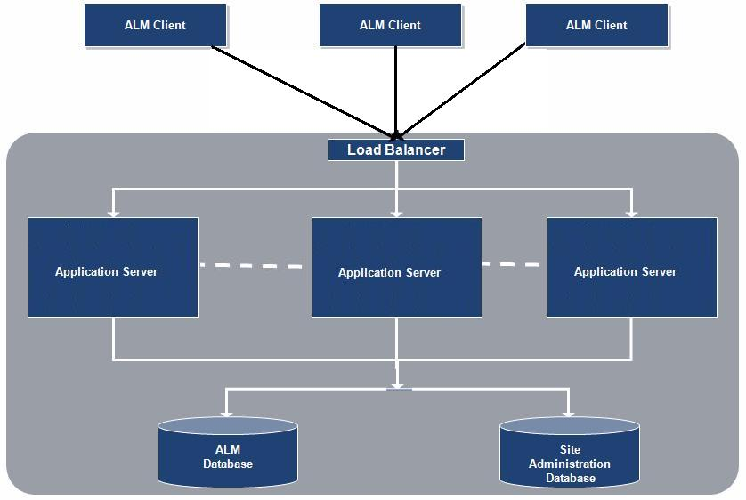

**Quality Center Workflow**

Quality Center workflow is represented using a simple diagram as shown below:

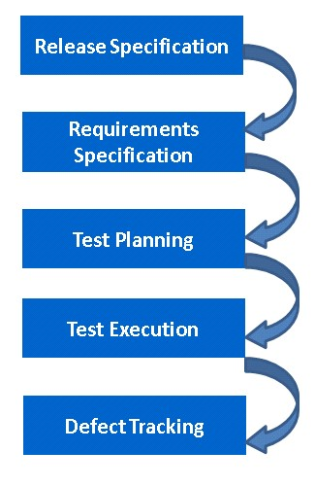

Download at <http://www8.hp.com/us/en/software-solutions/software.html?compURI=1174315>

After Installing we can also launch ALM by giving the following URL in [Internet Explorer[](http://www.tutorialspoint.com/)](http://www.tutorialspoint.com/) and ALM would be opened as shown :**URL : http://localhost:8181/qcbin/**

## Server Side Configurations

Once the Hp-ALM is [installed[](http://www.tutorialspoint.com/)](http://www.tutorialspoint.com/), we can continue to work with ALM only after [creating domain[](http://www.tutorialspoint.com/)](http://www.tutorialspoint.com/), project and users.

Below are the Steps to create Project, Domain and Users.

<http://www.tutorialspoint.com/qc/qc_server_side_configurations.htm>

## Requirements

Defining and Capturing Requirements is one of the key criteria for any software [development[](http://www.tutorialspoint.com/)](http://www.tutorialspoint.com/) process.

Describing Requirements refers to what needs to be done [to meet[](http://www.tutorialspoint.com/)](http://www.tutorialspoint.com/) the objectives during development.

Establishing requirements clearly and correctly upfront is very much emphasized so that there would be minimal/no rework after UAT.

The Requirements module enables users to define, describe, establish, capture, manage and track requirements at all stages of the [software[](http://www.tutorialspoint.com/)](http://www.tutorialspoint.com/) lifecycle.

The following are the key functionalities in requirements module and click on each link to know about that particular module.

|  |  |
| --- | --- |
| **Functionality** | **Description** |
| [Creating Requirements](http://www.tutorialspoint.com/qc/qc_create_req.htm) | Create requirements, assign to releases/cycles. |
| [Uploading Requirement](http://www.tutorialspoint.com/qc/qc_upload_req.htm) | Uploading requirements using ALM-MS Excel Addins |
| [Requirement Traceability](http://www.tutorialspoint.com/qc/qc_requirement_traceability.htm) | Enables how to define traceability links between requirements and dependencies that exist between the requirements. |
| [Traceability Matrix](http://www.tutorialspoint.com/qc/qc_traceability_matrix.htm) | Enables user to view the traceability matrix that lists source requirements and their associated requirements and tests. |

## Test Plan

The crucial step in testing any application is developing a clear and a precise test plan. A good test plan enables the team to assess the quality of the application under test at any point in the [software[](http://www.tutorialspoint.com/)](http://www.tutorialspoint.com/) development life cycle.

Following functionalities are very important in order to understand in the test plan module better. Click on each one of the functionalities to know more about it.

|  |  |
| --- | --- |
| **Functionality** | **Description** |
| [Creating Tests](http://www.tutorialspoint.com/qc/qc_create_tests.htm) | This module describes how to create folders of test subjects in the test plan tree and also to add tests. |
| [Uploading Tests](http://www.tutorialspoint.com/qc/qc_upload_tests.htm) | Uploading Tests using ALM-MS Excel Addins |
| [Requirement and Test Coverage](http://www.tutorialspoint.com/qc/qc_requirement_and_test_coverage.htm) | Enables how to define the relationship between the requirements and tests. |
| [Test Configuration](http://www.tutorialspoint.com/qc/qc_test_configuration.htm) | Specifies the subset of data or a run-time [environment[http://cdncache1-a.akamaihd.net/items/it/img/arrow-10x10.png](http://www.tutorialspoint.com/)](http://www.tutorialspoint.com/) that the test should use. |

<http://www.tutorialspoint.com/qc/index.htm>

____________________

<http://www.softwaretestinghelp.com/learn-hp-quality-center-qc-in-4-days/>

<https://my.vmware.com/web/vmware/downloads>

<http://guru99.com/quality-center-tutorials.html>